NAME: Shriya Ramya Mohan EXP :14
ROLL NO.:241901106

EXERCISE 14

TO CAPTURE, SAVE AND ANALYZE NETWORK TRAFFIC ON TCP/UDP/IP/HTTP/ARP/DHCP/ICMP/DNS USING WIRESHARK TOOL
AIM:
To capture, save, and analyse network traffic using Wireshark to understand protocol packet structures and develop competency in network analysis, troubleshooting, and security assessment.

ALGORITHM:
- Open Wireshark and check available network interfaces.
- Select an active interface (Ethernet/Wi-Fi) and start capture.
- Generate traffic (browse sites, ping, open apps).
- Stop the capture after enough packets are collected.
- Apply protocol filters like tcp, udp, icmp, dns, arp, dhcp, http.
- Analyze packets by checking headers and payload at each protocol layer.
- View statistics (Protocol Hierarchy, Conversations, Endpoints).
- Save the capture file in .pcap or .pcapng.
- Prepare report summarizing observations and conclusions.

OUTPUT:
- CAPTURE THE PACKET
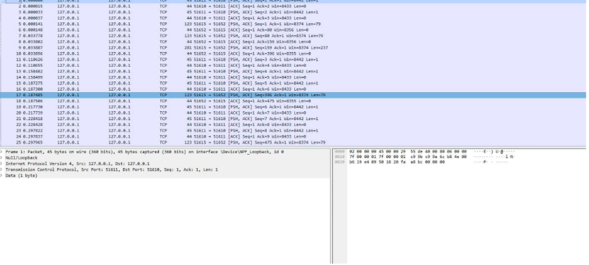
- CAPTURE THE TCP/UDP PACKETS
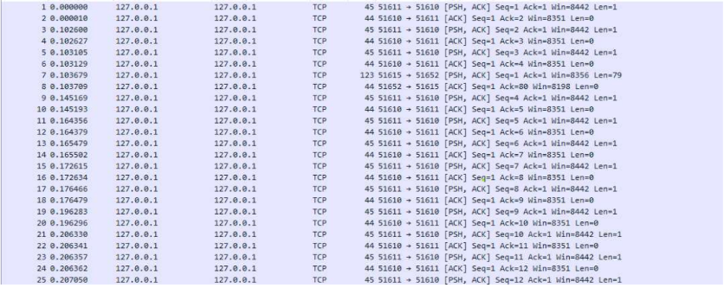
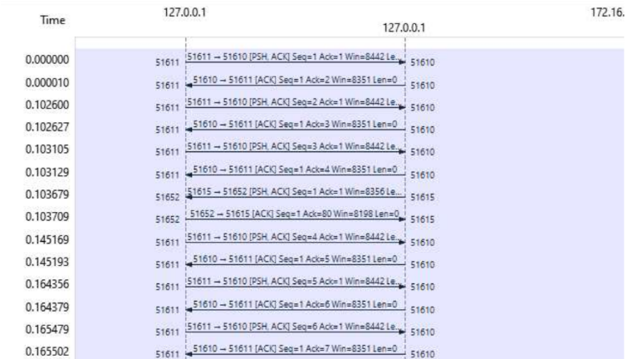
- CAPTURE ARP PACKET
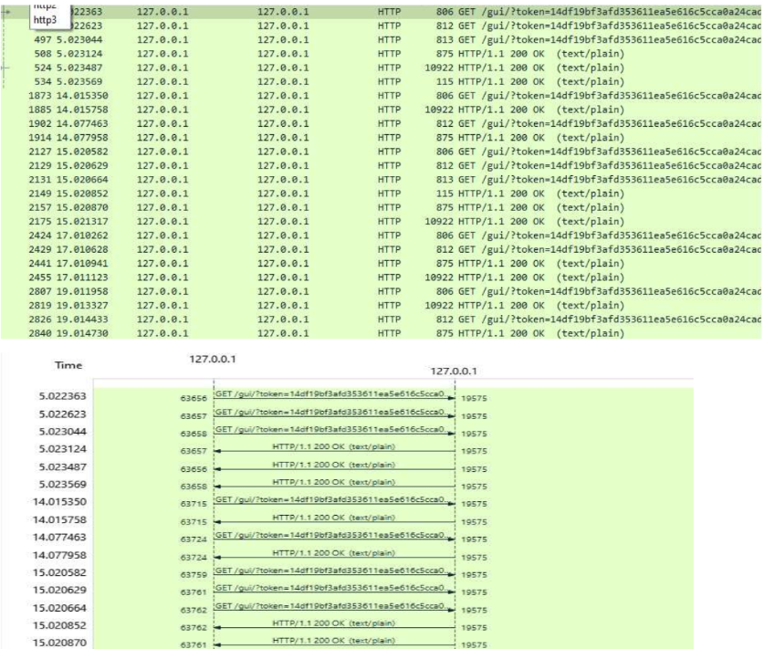

- CAPTURE IP/ICMP PACKETS
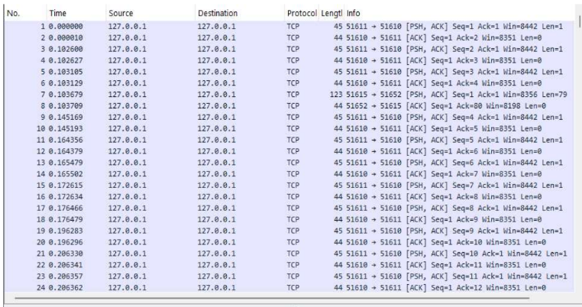

RESULT:
Wireshark captures and displays packets for all major protocols, enabling analysis of handshake sequences, address mappings, and network statistics across TCP, UDP, ICMP, ARP, DHCP, DNS, and HTTP.

